**PROJECT REPORT**

**ETHEREUM DECENTRALIZED IDENTITY**

**SMART CONTRACT**

**1.INTRODUCTION :**

**1.1 Project Overview:**

Inan era where digital identities are increasingly valuable yet vulnerable, the "EthereumDecentralised Identity Smart Contract" emerges as a groundbreaking solution. Leveraging the Ethereumblockchain's capabilities, this smart contract redefines identity management, offering enhanced security, transparency, and user autonomy.

Users can securely store their identity details on the Ethereumblockchain, safeguarded by its immutability and cryptographic principles.Unlike traditional systems, this decentralised approach eliminates single points of failure and minimises the risk of data breaches. Moreover, it empowers individuals with control over their own information, enabling selective sharing and revocation of access.

The EthereumDecentralised Identity Smart Contract represents a paradigm shift in identity management, where trust is established through blockchain consensus and verification occurs end-to-end, enhancing security and reducing fraud.

This innovation not only ensures the integrity of personal information but also opens doors to a wide range of applications, from secure voting systems to streamlined financial transactions, all underpinned by a resilient and transparent identity management framework.

**1.2 Purpose:**

**Informing and educating :**The content seeks to inform readers about the existence of this innovative identity management solution, its feature and its benefits.

**Highlighting Innovation**: It emphasize the innovative nature of the ethereum decentralized identity smart contract and how it differs from traditionl identity management systems.

**Highlighting Advocating for Blockchain Technology:** The content advocates for the use of blockchain technology, specifically the Ethereumblockchain, as a secure and transparent platform for indentity management, aaddressing the vulnerabilities of digital identities.

**Emphasizing Benefits:** It highlights the advantages of the solution, such as enhanced security,Transparency ,user autonomy, and the reduction of data breaches.

**2.LITERATURE SURVEY**

**2.1 Existing problem**

It introduces the general context and mentions the emergence of smart contracts, which are computer protocols designed to automate and enforce agreements without the need for intermediaries. However, it also points out that despite the potential benefits, there are concerns such as security, vulnerabilities, and legal issues associated with smart contracts.

The passage outlines the structure of the paper, indicating that it will provide a comprehensive survey of blockchain-enabled smart contracts, including technical and usage perspectives. It mentions the creation of a taxonomy for existing solutions, categorization of research papers, and discussion of related studies. Additionally, it hints at the identification of challenges and open issues that require attention in future research and the exploration of future trends.

The existing system or the core findings and details of the research paper would likely be presented in the main body of the paper, following this introductory section. The paper will likely delve into various blockchain-enabled smart contract solutions, their technical aspects, real-world use cases, and the challenges associated with their adoption and implementation.

**2.2 References:**

# 1.[Veneta Aleksieva](https://ieeexplore.ieee.org/author/37086919475); [HristoValchanov](https://ieeexplore.ieee.org/author/37086921751); [Anton Huliyan](https://ieeexplore.ieee.org/author/37087322880), Application of Smart Contracts based on EthereumBlockchain for the Purpose of Insurance Services,2019.

2.Angiulli, F., Fassetti, F., Furfaro, A., Piccolo, A., Sacc`a, D.: Achieving service accountability through blockchain and digital identity. In: International Conference on Advanced Information Systems Engineering. pp. 16–23. Springer (2018)

3. Banerjee, A.: Blockchain technology: Supply chain insights from erp. Advances in Computers (2018)

4.Buccafurri, F., Lax, G., Russo, A., Zunino, G.: Integrating digital identity and blockchain. In: OTM Confederated International Conferences” On the Move to Meaningful Internet Systems”. pp. 568–585. Springer (2018)

5. Al-Bassam, M.: Scpki: A smart contract-based pki and identity system. In: Proceedings of the ACM Workshop on Blockchain, Cryptocurrencies and Contracts. pp. 35–40. ACM (2017)

6. Cohn, A., West, T., Parker, C.: Smart after all: Blockchain, smart contracts, parametric insurance, and smart energy grids. Georgetown Law Technology Review 1(2), 273–304 (2017)

7. Dai, F., Shi, Y., Meng, N., Wei, L., Ye, Z.: From bitcoin to cybersecurity: A comparative study of blockchain application and security issues. In: Systems and Informatics (ICSAI), 2017 4th International Conference on. pp. 975–979. IEEE (2017)ss

8. Jacobovitz, O.: Blockchain for identity management. The Lynne and William Frankel Center for Computer Science Department of Computer Science. Ben-Gurion University, Beer Sheva Google Scholar (2016)

9. Buccafurri, F., Fotia, L., Lax, G.: Implementing advanced electronic signature by public digital identity system (spid). In: International Conference on Electronic Government and the Information Systems Perspective. pp. 289–303. Springer (2016)

10. Buccafurri, F., Fotia, L., Lax, G., Mammoliti, R.: Enhancing public digital identity system (spid) to prevent information leakage. In: International Conference on Electronic Government and the Information Systems Perspective. pp. 57–70. Springer (2015)

**2.2 Problem Statement Definition**

Ethereum decentralized identity smart contracts, a problem statement definition typically outlines the specific challenges or issues that the smart contract aims to address. Here's a general structure for a problem statement:

**Background:** Provide a brief introduction to the concept of decentralized identity on the Ethereumblockchain.

**Problem Description:** Clearly define the problem or challenges that the smart contract is designed to solve. This may include issues related to identity verification, privacy, security, or user control over personal data.

**Objectives**: List the main goals and objectives of the decentralized identity smart contract. These objectives should directly align with the identified problems.

**Scope:** Define the scope of the smart contract, specifying what it will and won't cover in terms of identity management.

**Key Features:** Highlight the key features or functions that the smart contract will provide to address the identified problems. This may include identity creation, verification, revocation, and data management.

**Stakeholders:** Identify the primary stakeholders involved in this decentralized identity system, such as users, identity issuers, and relying parties.

**Constraints and Assumptions**: Specify any constraints or assumptions that the smart contract relies on, such as the use of specific Ethereum standards or third-party services.

**Benefits**: Describe the potential benefits of implementing the decentralized identity smart contract, such as enhanced security, user control, or reduced reliance on centralized identity providers.

**Risks and Challenges:** Identify potential risks and challenges that may arise during the implementation and deployment of the smart contract, including legal and regulatory concerns.

**Success Criteria:** Define the criteria that will be used to measure the success of the smart contract in addressing the identified problems.

**Implementation and Timeline:** Provide an overview of the implementation plan and a rough timeline for the development and deployment of the smart contract.

# 3.IDEATION &PROPOSED SOLUTION:

**3.1 Empathy Map Canvas:**

# 3.2 IDEATHON AND BRAINSTROMING:

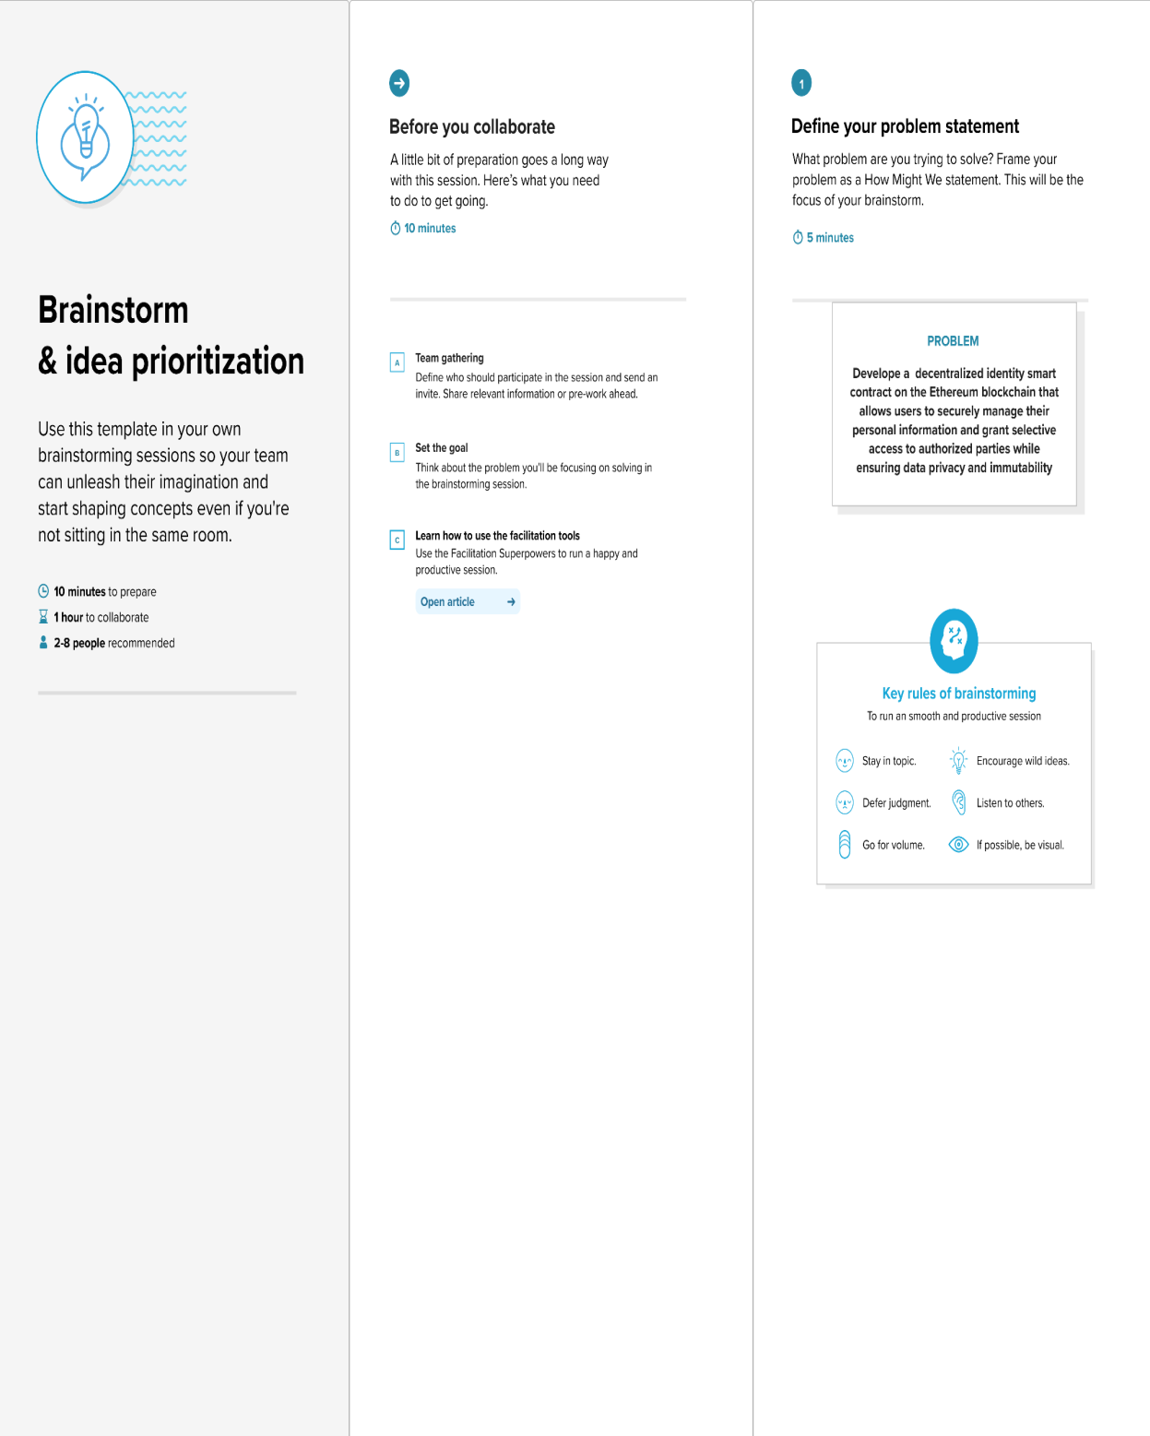

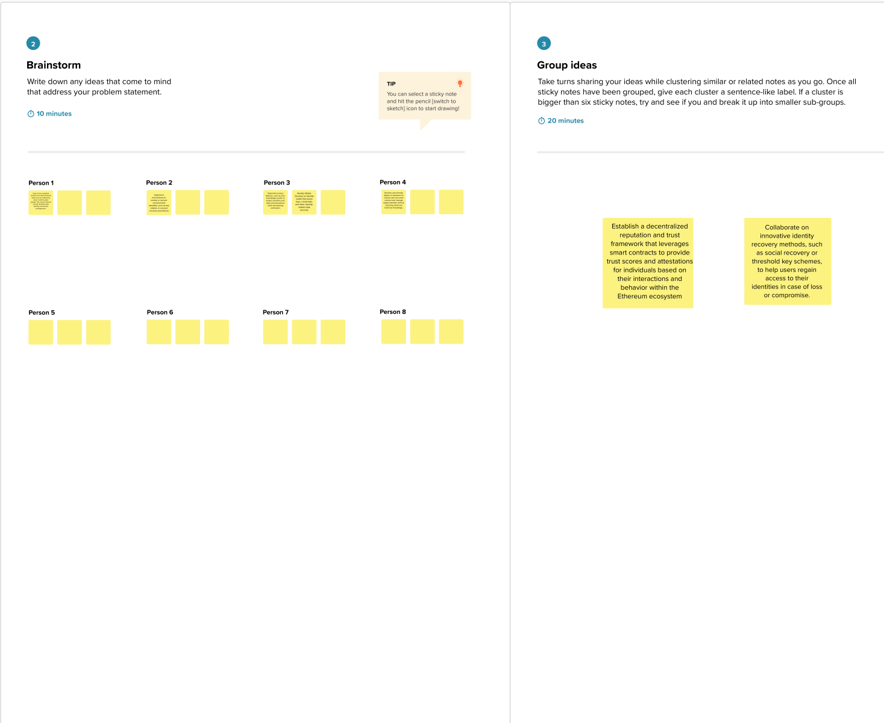

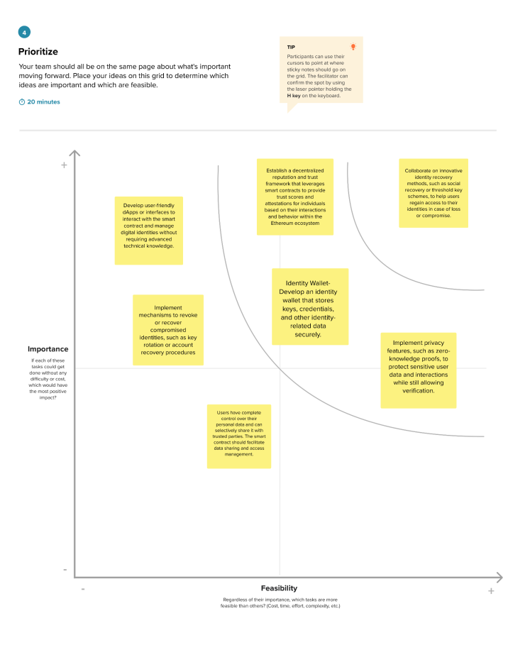

# 4.REQUIREMENTANALYSIS:

# 4.1Functionalrequirement:

1.**User Registration and Identity Creation:**

* Users must be able to create digital identities on the Ethereumblockchain.
* Each identity should be associated with a unique Ethereum address.
* The system should support both individual and organizational identities.

2**. Identity Verification:**

* Users must have the ability to verify their identities through trusted identity issuers.
* The smart contract should allow for the inclusion of identity credentials, such as government-issued IDs or educational certificates.

3. **Identity Revocation:**

* Users should be able to revoke or update their identity credentials as necessary.
* Revocation should be recorded on the blockchain and reflect the latest status of the identity.

4. **Privacy and Data Management:**

* Users must have control over who can access their identity data.
* The smart contract should implement data encryption and protection mechanisms.
* Data should be stored securely on the blockchain, ensuring data integrity and confidentiality.

5. **Interoperability and Standards:**

* The smart contract should adhere to relevant Ethereum and identity-related standards, such as ERC-725 and ERC-735.
* Ensure compatibility with other decentralized identity solutions and protocols.

**6. User-Friendly Interface:**

* Develop a user-friendly interface, such as a decentralized application (DApp), to interact with the smart contract.
* Consider mobile and web-based interfaces for accessibility.

**7. Regulatory Compliance**:

* Ensure compliance with relevant legal and regulatory requirements, including data protection laws.

**8. Decentralization and Security:**

* Implement robust security measures to prevent unauthorized access and protect against identity theft.
* Leverage Ethereum's decentralization for enhanced security and resilience.

**9. Smart Contract Upgradability:**

* Design the smart contract to be upgradable to incorporate future improvements or address emerging security vulnerabilities.

**10. Testing and Quality Assurance:**

* Conduct thorough testing, including unit, integration, and security testing, to ensure the reliability and security of the smart contract.

**11. Documentation and Training:**

* Provide comprehensive documentation for users and developers on how to use the decentralized identity system.
* -Offer training and educational resources for identity issuers and relying parties.

**12. Scalability and Performance:**

* Consider the scalability of the smart contract to handle a growing number of users and identity records while maintaining performance.

**13. Monitoring and Analytics:**

* Implement monitoring and analytics tools to track the usage and health of the decentralized identity system.

**14. Deployment and Maintenance:**

* Plan for the deployment of the smart contract on the Ethereum network.
* Establish procedures for ongoing maintenance and updates.

**15. User Support and Dispute Resolution:**

* Provide mechanisms for user support and dispute resolution in case of identity-related issues or conflicts.

**2.2 Non-Functionalrequirements:**

**1. Security:**

* The smart contract must implement robust security measures to protect against unauthorized access, data breaches, and identity theft.
* It should adhere to best practices in secure coding and data encryption.

**2. Scalability:**

* The system should be designed to handle a growing number of users and identity records without compromising performance.
* Ensure efficient storage and retrieval of identity data.

**3. Performance:**

* The smart contract should provide low-latency response times for identity verification and data retrieval.
* Implement performance optimizations for efficient blockchain transactions.

**4. Availability and Reliability:**

* The system should be highly available, with minimal downtime.
* Implement redundancy and failover mechanisms to ensure continuous operation.

**5. Privacy and Consent Management:**

* Users should have granular control over who can access their identity data.
* The system must respect user consent and ensure privacy by design.

**6. Compliance and Legal Requirements:**

* Adhere to legal and regulatory requirements, including data protection laws (e.g., GDPR) and blockchain-specific regulations.

**7. Interoperability:**

* Ensure that the smart contract can interact with other decentralized identity solutions and standards, promoting interoperability within the blockchain ecosystem**.**

**8. Auditability and Traceability:**

* Enable audit trails for identity verification and data access.
* Ensure that all transactions and changes to identities are traceable on the blockchain.

**9. Usability:**

* Provide an intuitive and user-friendly interface for both identity owners and identity issuers.
* Consider accessibility standards for a diverse user base.

**10. Disaster Recovery:**

* Develop a disaster recovery plan to restore the system in the event of unforeseen failures or attacks.

**11. Testing and Quality Assurance:**

* Implement a comprehensive testing strategy, including security testing, to ensure the reliability of the smart contract.
* Perform regular security audits and code reviews.

**12. Documentation:**

* Provide clear and comprehensive documentation for developers, identity issuers, and users.
* Include instructions for integrating with the smart contract and troubleshooting common issues.

**13 Community Engagement:**

* Foster an active and engaged community around the decentralized identity system.
* Encourage feedback and contributions to improve the project.

**14. Environmental Impact:**

* Consider the environmental impact of blockchain transactions and implement energy

efficient solutions if possible.

# 5. PROJECT DESIGN:

**5.1 DATA FLOW DIAGRAM**

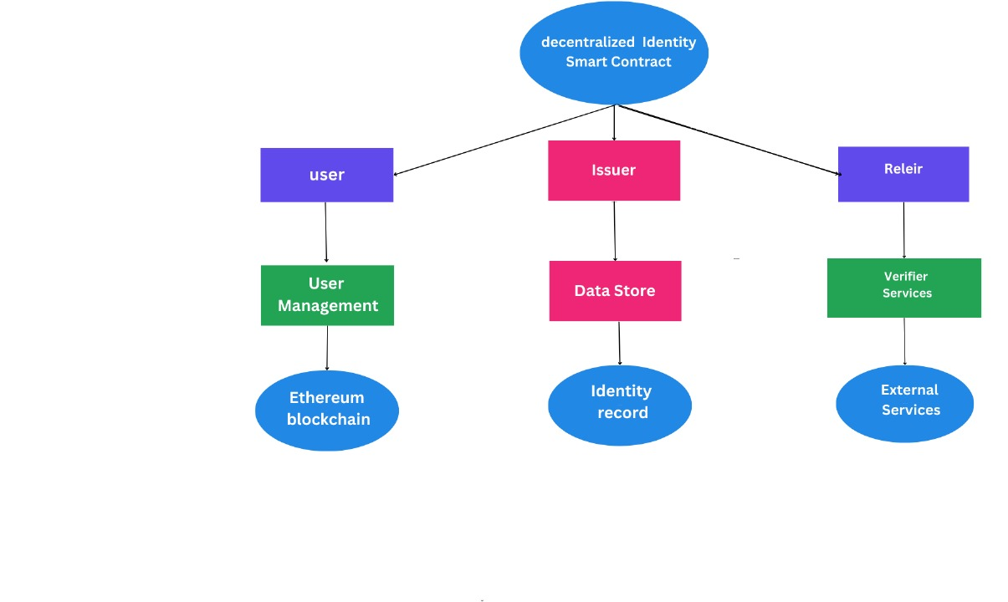

**5.2Solution Architecture:**

# 

# 6.PROJECT PLANNING:

**6.1Technical Stack**

# 

7.CODING AND SOLUTIONING:

**1. Smart Contract Development:**

* Develop Ethereum smart contracts to handle identity creation, management, verification, and revocation.
* Follow Ethereum standards such as ERC-725, ERC-735, and ERC-1484 for identity management.
* Implement access control and permission management within the smart contract to protect user data.

**2. User Interface Development**:

* Create user-friendly interfaces, such as a web-based or mobile application (DApp), for users to interact with the smart contract.
* Design interfaces for identity issuers and relying parties for verification purposes.

**3. Identity Verification:**

* Establish a process for identity verification where identity issuers can verify users' identity credentials and issue digital certificates.
* Implement cryptographic techniques to ensure the authenticity of identity data.

**4. Data Storage and Privacy:**

* Design a secure and efficient data storage mechanism for identity records on the Ethereumblockchain, considering gas costs.
* Implement encryption and access control measures to protect user data and privacy.**5. Interoperability:**
* Ensure that the smart contract can interoperate with other identity solutions and standards, promoting compatibility with the broader ecosystem.

**7.1 Feature:**

A decentralized identity project on the Ethereumblockchain should offer a comprehensive set of features to provide secure, user-controlled identity management. Below are key features that such a project should consider implementing: Identity Creation and Registration,Security,Scalability,etc.

**8. PERFORMANCE TESTING:**

|  |  |  |  |
| --- | --- | --- | --- |
| **S.No.** | **Parameter** | **Values** | **Screenshot** |
| 1. | Information gathering | Setup all the Prerequisite: | Screenshot (32).png |
| 2. | Extract the zip files | Open to vscode | Screenshot (33).png |

|  |  |  |  |
| --- | --- | --- | --- |
| 3. | Remix Ide platform explorting | Deploy the smart contract code  Deploy and run the transaction.By selecting the environment - inject the MetaMask. | Screenshot (27).png |
| 4 | Open file explorer | Open the extracted file and click on the folder.  Open src,and search for utiles.  Open cmd enter commands   1. Npm install 2. Npm bootstrap 3. Npm start | Screenshot (34).png |
| 5 | {LOCALHOST IP ADDRESS | copy the address and open it to chrome so you can see the frontend of your project. | Screenshot (133).png |

**9.RESULT**:

**9.1 Output Screenshots**: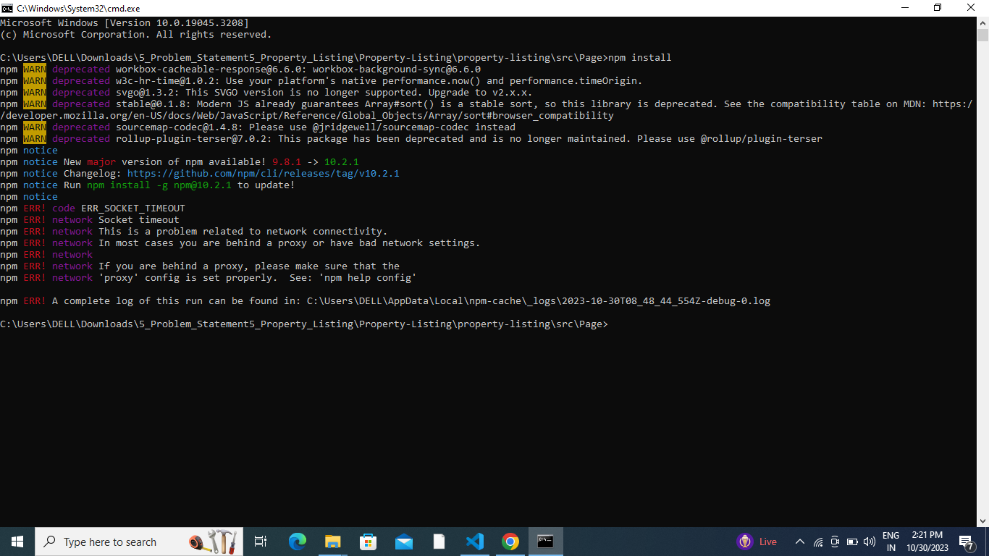

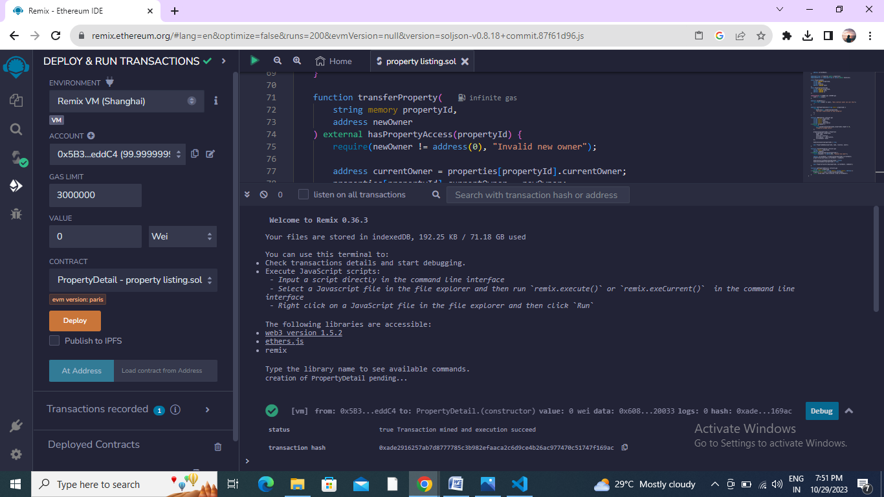

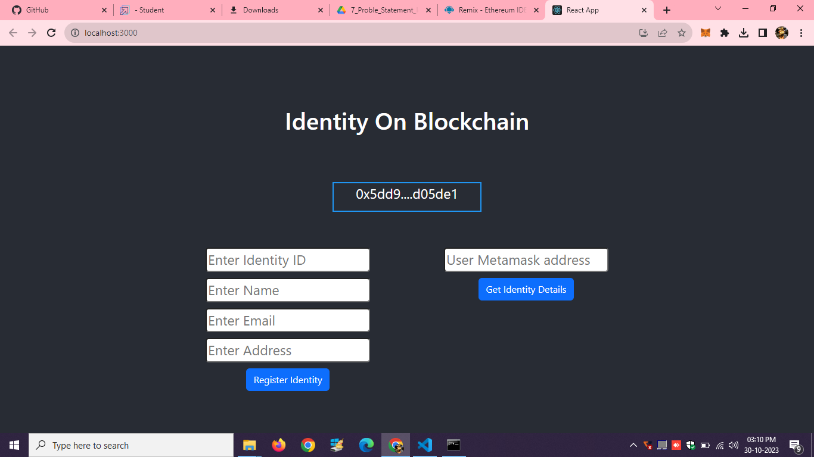

**10.ADVANTAGES AND DISADVANTAGES:**

* 1. **Advantages:**

**1.Self-Sovereign Identity:**

DIDs allow individuals to have more control over their digital identities. Users can create and manage their DIDs without relying on central authorities, such as governments or corporations.

**2.Privacy:**

DIDs can enhance privacy by allowing users to share only the information they choose with others. It minimizes the amount of personal data exposed during transactions or interactions**.**

**3.Security:**

The Ethereum blockchain's decentralized and immutable nature provides a high level of security for DIDs. It's challenging for malicious actors to tamper with or forge identity data stored on the blockchain.

**4. Interoperability:**

Ethereum-based DIDs can be integrated with other blockchain-based applications and services, promoting interoperability and cross-platform identity solutions**.**

**10.2 Disadvantages:**

**1. Scalability:**

Ethereum has faced scalability issues, leading to high gas fees and slow transaction processing. This can hinder the adoption and efficiency of DID smart contracts.

**2.Key Management:**

Users are responsible for managing their private keys securely. Losing access to these keys can result in the loss of their digital identity.

**3. Regulatory and Legal Challenges:**

The decentralized and pseudonymous nature of DIDs can pose challenges for regulators and governments in terms of identity verification, taxation, and legal enforcement.

**4. Costs:**

Using Ethereum for DID smart contracts can be costly due to gas fees. This can make it less accessible for individuals with limited resources.

**11. CONCLUSION:**

Ethereum-based decentralized identity (DID) smart contracts offer several notable advantages, such as self-sovereign identity, enhanced privacy and security, interoperability, transparency, and a reduction in identity theft. These benefits hold great promise for the future of digital identity management.

However, there are also important disadvantages to consider, including scalability challenges, complexity in development and key management, potential regulatory and legal hurdles, costs associated with Ethereum gas fees, and ongoing concerns about data privacy.

The adoption and success of Ethereum-based DID smart contracts will depend on continued technological advancements, regulatory developments, and user education. As the blockchain ecosystem evolves and addresses some of these challenges, it's possible that decentralized identity solutions will become more accessible and widely adopted, leading to a more secure and user-centric digital identity landscape.

**12. FUTURE SCOPE:**

The future scope for Ethereum-based decentralized identity (DID) smart contracts is highly promising, characterized by ongoing advancements and trends that can revolutionize digital identity management. As Ethereum and other blockchain platforms work on scalability solutions and interoperability, the cost-effectiveness and efficiency of DID smart contracts are expected to improve, reducing gas fees and enhancing overall performance.

The establishment of widely accepted standards and governance for DIDs will foster compatibility and security, while privacy enhancements, such as zero-knowledge proofs and off-chain storage, will address growing concerns about data protection. Moreover, user-friendly applications, regulatory frameworks, and applications beyond identity verification will further drive the adoption and integration of DIDs into various sectors.

As global adoption grows, the future of decentralized identity is poised to create a more secure, user-centric, and privacy-conscious digital identity landscape, with the potential to extend its reach to IoT devices, mobile applications, and various other innovative use cases.

**13. APPENDIX**

**13.1 Source Code:**

// SPDX-License-Identifier: MIT

pragma solidity ^0.8.0;

contract Identification{

address public owner;

struct Identity {

string identityId;

string name;

string email;

string contactAddress;

uint256 registrationTimestamp;

}

mapping(address => Identity) public identities;

event IdentityRegistered(

address indexed owner,

string identityId,

string name,

string email,

uint256 registrationTimestamp

);

constructor() {

owner = msg.sender;

}

modifier onlyOwner() {

require(msg.sender == owner, "Only contract owner can call this");

_;

}

modifier notRegistered() {

require(

bytes(identities[msg.sender].identityId).length == 0,

"Identity already registered"

);

_;

}

function registerIdentity(

string memory identityId,

string memory name,

string memory email,

string memory _address

) external notRegistered {

require(bytes(identityId).length > 0, "Invalid identity ID");

require(bytes(name).length > 0, "Invalid name");

require(bytes(email).length > 0, "Invalid email");

identities[msg.sender] = Identity({

identityId: identityId,

name: name,

email: email,

contactAddress : _address,

registrationTimestamp: block.timestamp

});

emit IdentityRegistered(

msg.sender,

identityId,

name,

email,

block.timestamp

);

}

function getIdentityDetails(

address userAddress

)

external

view

returns (string memory, string memory, string memory, string memory,uint256)

{

Identity memory identity = identities[userAddress];

return (

identity.identityId,

identity.name,

identity.email,

identity.contactAddress,

identity.registrationTimestamp

);

}

}

**13.2 Github and Project Demo Link**